IPE 4111
Industrial Management

Table of Contents
Spring 2021 MPE 2

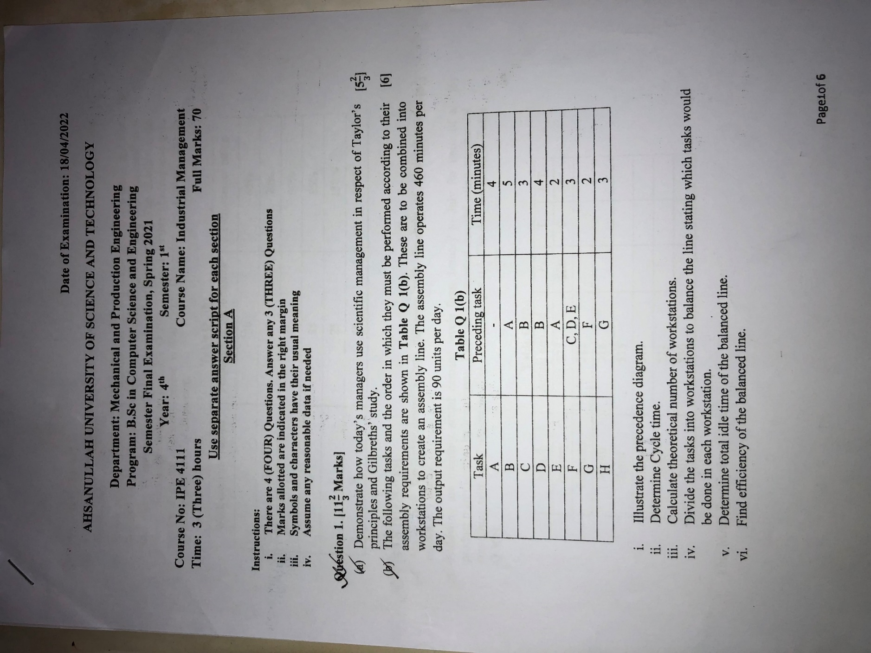
Spring 2021 MPE
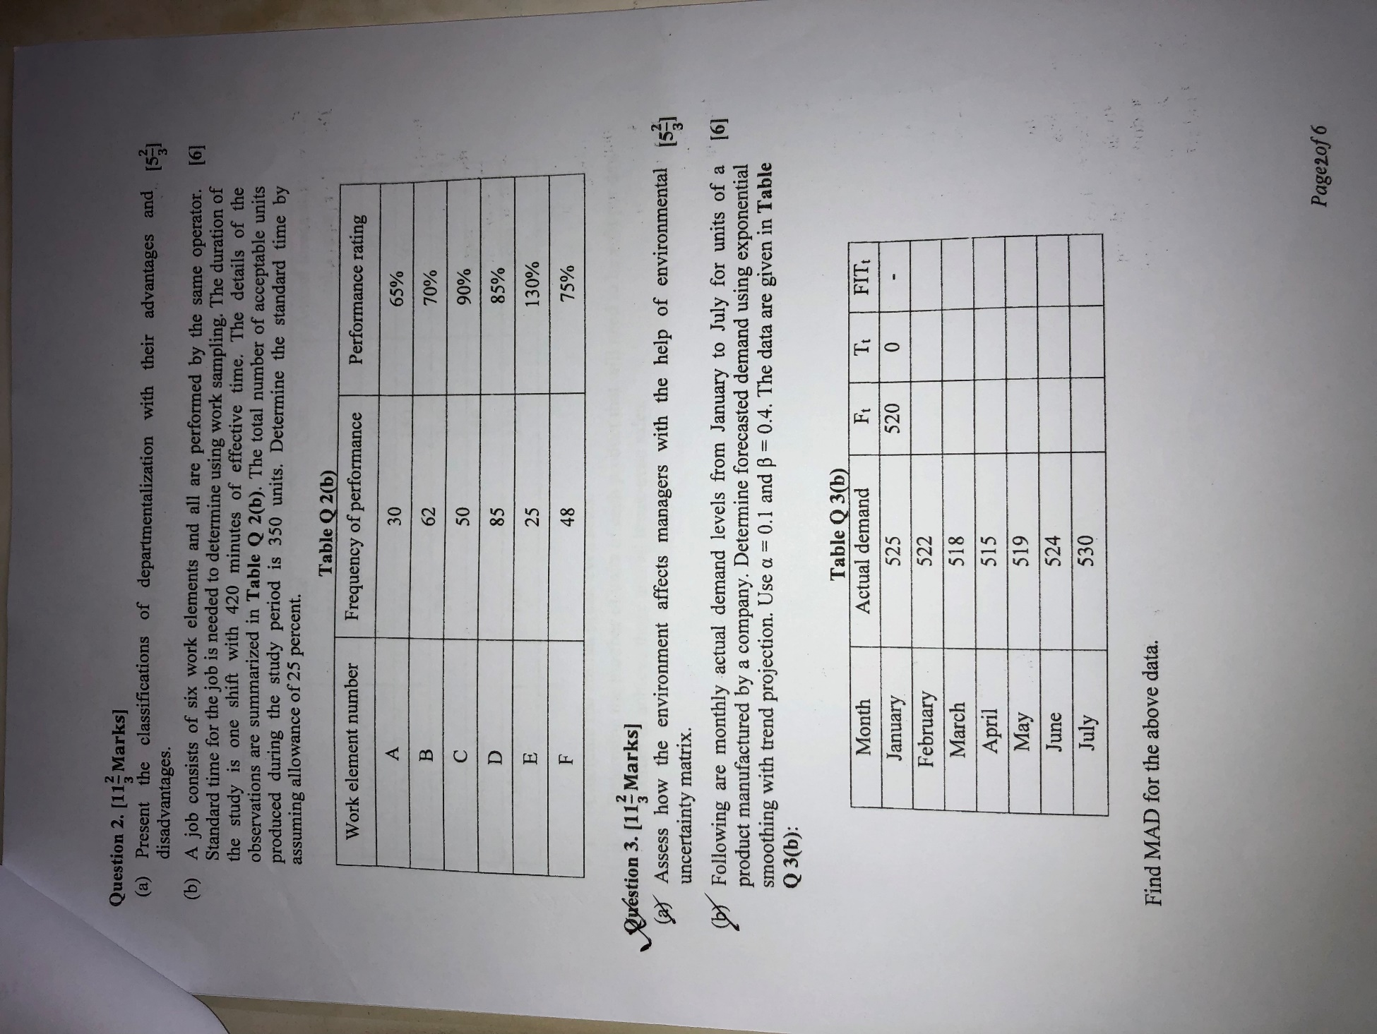
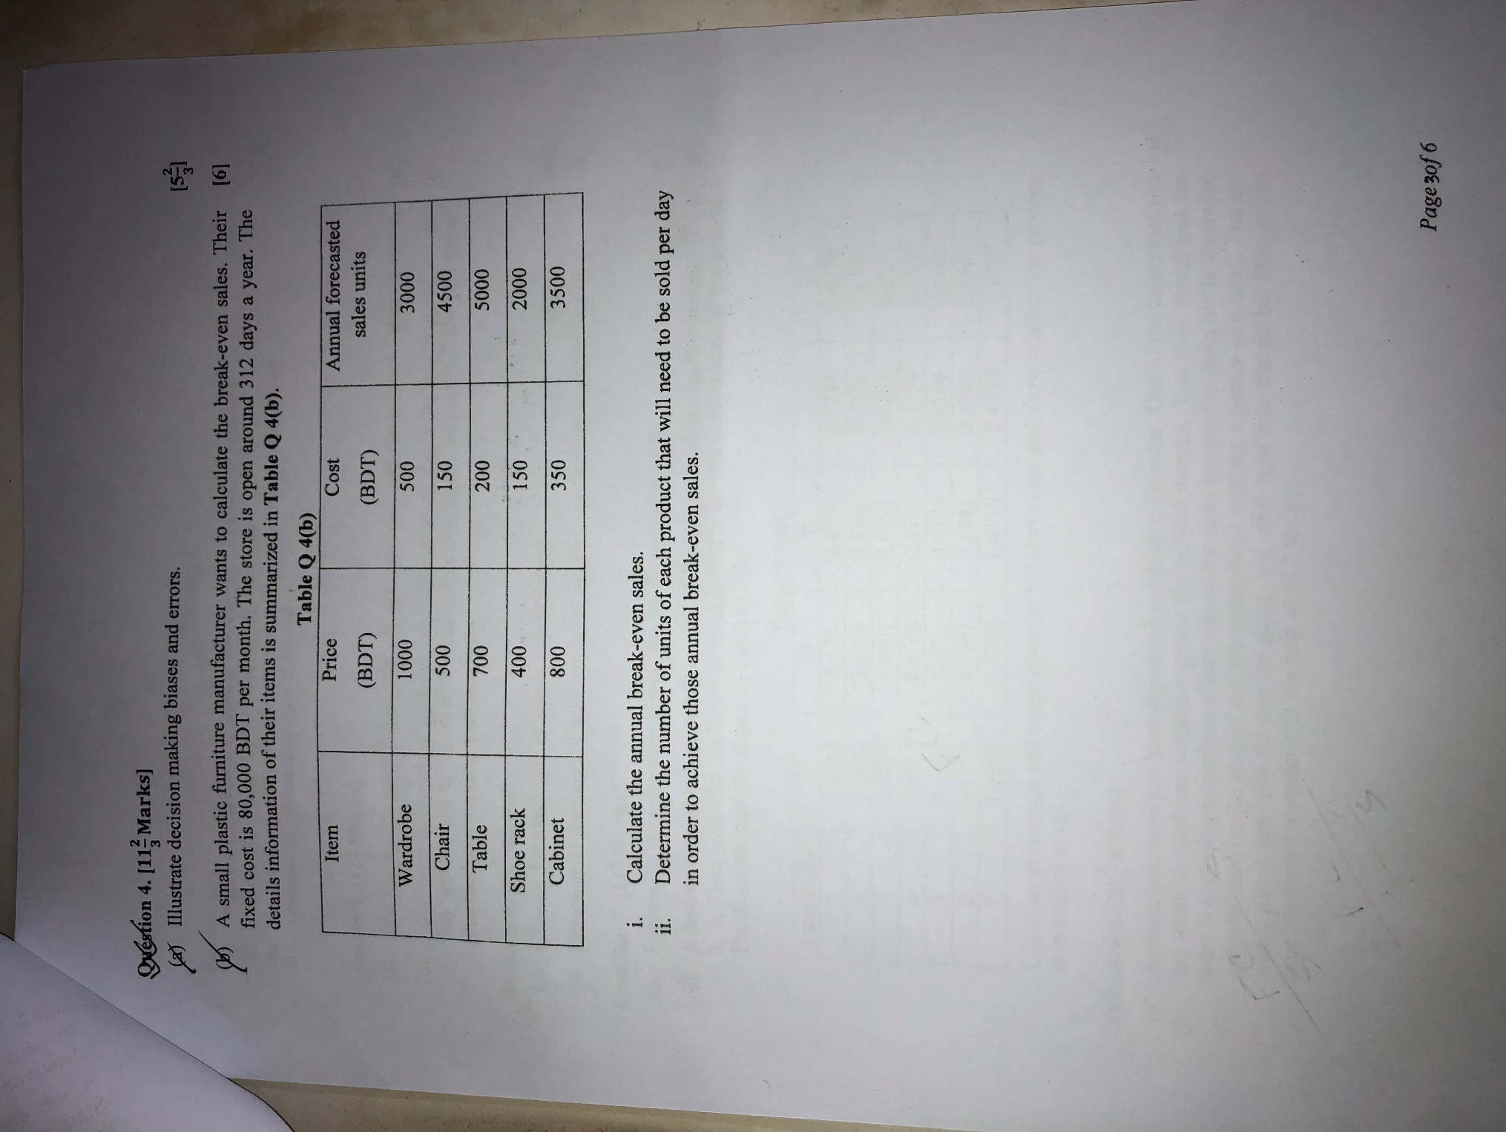
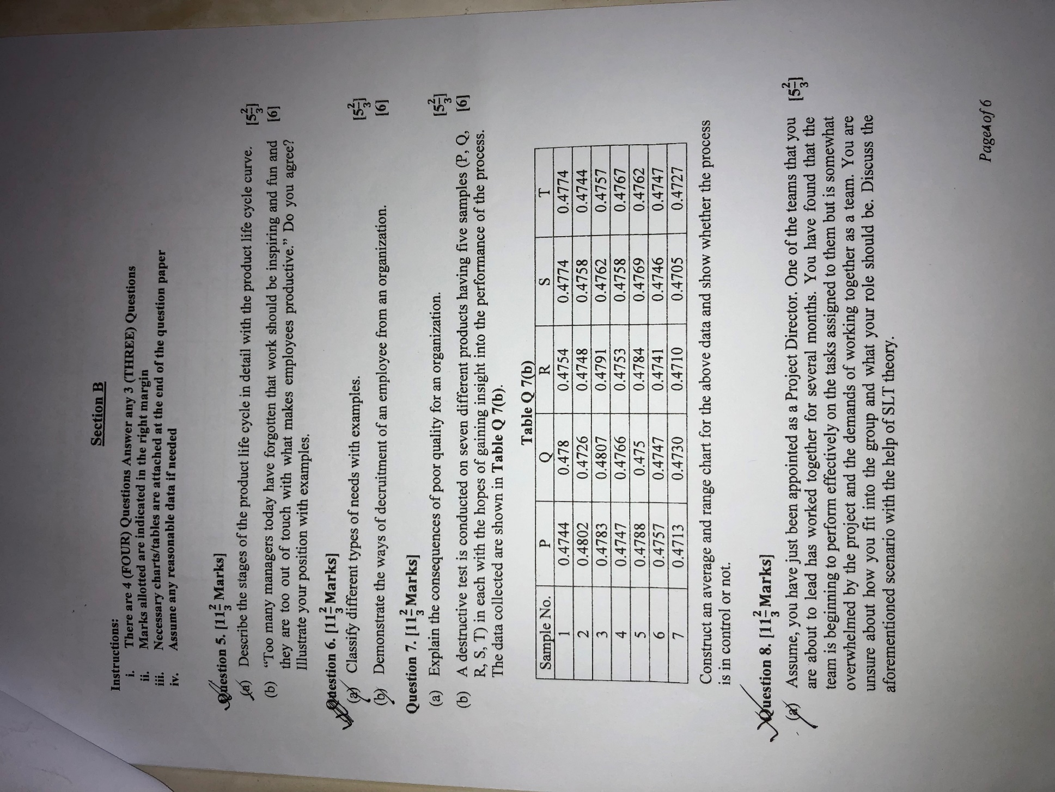
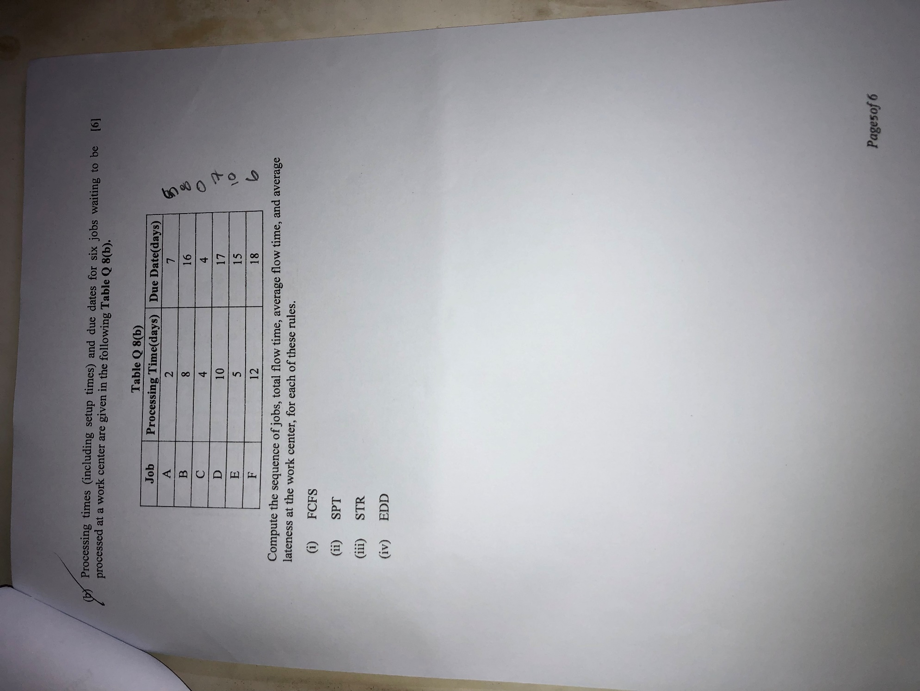
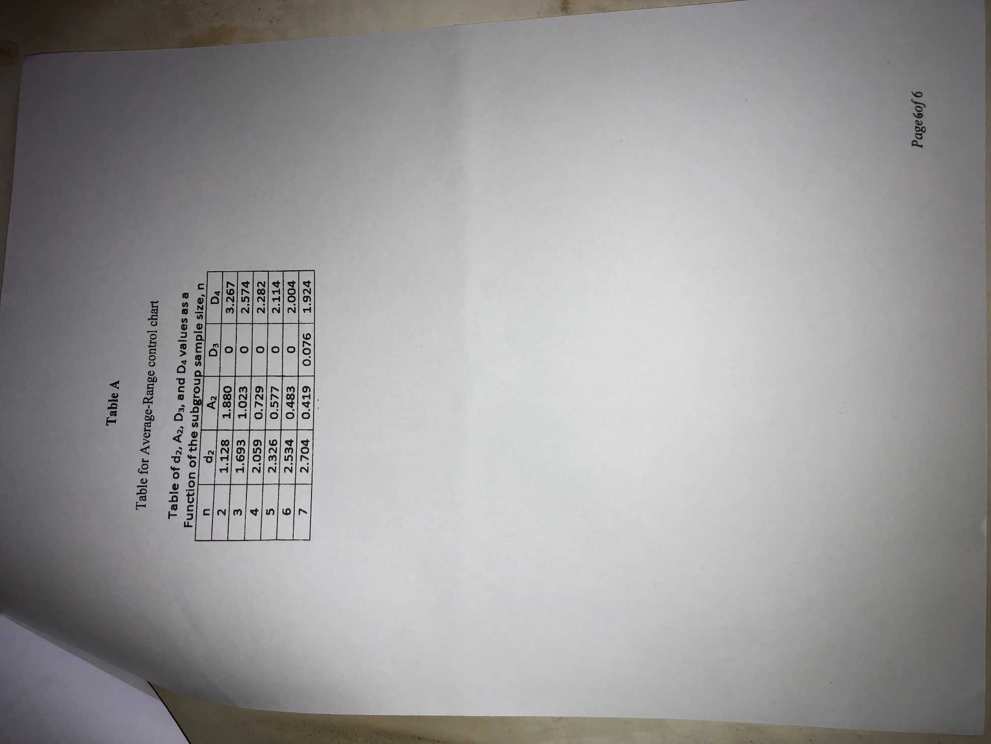

ME Fall 2020

Part A
There are 3 (Three) Questions. Answer any 2 (Two).

Question 1. [Marks: 12.5]
- Discover if a manager can perform more than one managerial role at a time with the help of examples.
- The following tasks and the order in which they must be performed according to their assembly requirements are shown in Table Q 1(b). These are to be combined into workstations to create an assembly line. The assembly line operates 540 minutes per day. The output requirement is 36 units per day.

[5.5]

[7]

Table Q 1(b)

Task | Preceding task | Time (minutes)
A | - | 8
B | A | 6
C | A | 4
D | B,C | 5
E | C | 7
F | D | 5
G | E | 8
H | F | 7
I | F | 5
J | H, I, G | 8

  - Illustrate the precedence diagram.
  - Determine Cycle time.
  - Calculate theoretical number of workstations.
  - Divide the tasks into workstations to balance the line stating which tasks would be done in each workstation.
  - Determine total idle time and efficiency of the balanced line.

Question 2. [Marks: 12.5]
- Assess how organizational culture fosters higher organizational performance. [5.5]

- A job consists of seven work elements and all are performed by the same operator. Standard time for the job is needed to determine using work sampling. The duration of the study is one shift with 2400 minutes of effective time. The details of the observations are summarized in Table Q 2(b). The total number of acceptable units produced during the study period is 560 units. Determine the standard time by assuming allowance of 15 percent.

Q 2(b)
[7]

Work element number | Frequency of performance | Performance rating
1 | 55 | 85%
2 | 80 | 89%
3 | 70 | 120%
4 | 65 | 110%
5 | 50 | 80%
6 | 55 | 75%
7 | 45 | 85%

Question 3. [Marks: 12.5]
- Demonstrate how effective decisions can be made in today's world. [5.5]

- A car shop owner wants to forecast car sales by weighting the past three months, with more weight given to recent data to make them more significant. Actual sales till October and weights are given in Table Q 3(b1) and Table Q 3(b2) respectively. Calculate forecast till November Determine forecast error using MAPE if actual sales for November is 83.
[7]

Table Q 3(b1) Table Q 3(b2)
Month | Actual sales
January | 49
February | 51
March | 58
April | 55
May | 61
June | 65
July | 68
August | 73
September | 77
October | 79

Weights Applied | Period
3 | Last month
2 | Two months ago
1 | Three months ago

Part B

There are 3 (Three) Questions. Answer any 2 (Two).
Question 4. [Marks: 12.5]

- “Instead of worrying about job satisfaction to motivate workers, companies should be trying to create a competitive environment where performance is enabled”—explain in terms of motivation theories you have studied in this course.
- Suppose an HRM manager has been transferred from one branch of a company in United States to another branch of the same company in India. Illustrate the challenges that he needs to confront in his new workplace.

Question 5. [Marks: 12.5]
- An organizational survey shows that most workers rate having a caring boss even higher than they value money or fringe benefits-- discuss the implications of this information.
- Do you agree or disagree with the following statement?
“Information technology helps managers to be more effective and efficient.”
Use specific reasons and examples to support your position.
Question 6. [Marks: 12.5]

- Illustrate an assignment plan to minimize the total costs of the given data as shown in Table Q 6(a).

[6]

[6.5]

[6]

[6.5]

[6]

Table Q 6(a)
Route

 | A | B | C | D | E
1 | 4 | 5 | 9 | 8 | 7
2 | 6 | 4 | 8 | 3 | 5
3 | 7 | 3 | 10 | 4 | 6
4 | 5 | 2 | 5 | 5 | 8
5 | 6 | 5 | 3 | 4 | 9

Assume, ABC company plans to launch e-business in Bangladesh. Prepare a SWOT analysis for ABC company. [6.5]
Truck

